Angular Assignment

Q1: Create a form to fill data and show the data in tabular form.

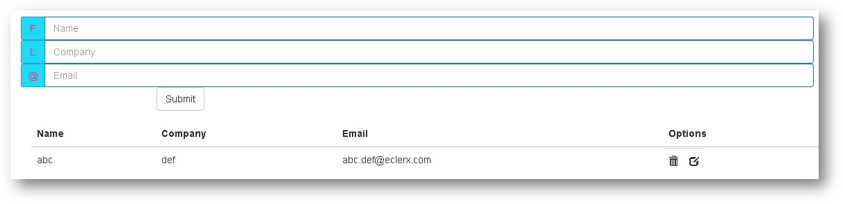

Q2: Use Geolocation of HTML5 to get location of user and display the location in Google map using Angular

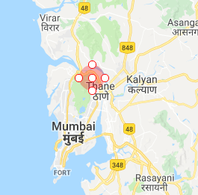

Q3: Create a single page with tabs as shown below. Create separate component for each tab. Assume any data. Use bootstrap for styling.

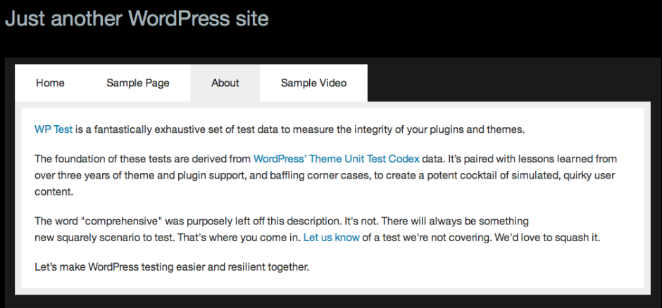

Q4: Display the data in tabular grid. (Data can be read from json <https://jsonplaceholder.typicode.com/todos> or some array)

Allow the user to make inline modification to data and reflect the changes in table accordingly.

Q5: Use json (<https://jsonplaceholder.typicode.com/comments>) to display user email address and body in the form of cards. Create a drop down of a to z alphabets. Whenever user select “a” in dropdown, only those cards should be shown whose domain name in email address starts with “a”.

